Team Name: Alpha Coderz

Member Name: Prabhsimran Singh

Student Id: N01528638

Task done previous week:

|  |  |  |
| --- | --- | --- |
| Tasks List | Hours | Remarks/References |
| Hosting Website on Cyclic with team members | 1.5 | Deployed our web application on Cyclic.  **Issues faced**: We pushed the code to git but didn’t pushed the react build folder. As a result, our deployed website was giving error.  Later we started to look for problems, we found that build folder was not pushed to git giving errors.  Our website is hosted at:  https://alphacoderz.cyclic.app/ |
| Meeting with sponsor | 30 Mins | In this meeting , we basically discussed about our project progress.They gave us feedback in this meeting and suggested to speed up the development |
| Internal Team Meeting | 45 Mins | Discussed about the feedback we got from sponsors and our next steps, in which I have to start integeration of frontend with API’s. |
| Intergeration Of Frontend | 5 hours | Was working on search APIs for dashboard in which user can search Projects and showing results.  Also, integerated Create Project Folder API for creating new project by Lab. I will attach the screenshots after the table.  **Issues Faced -** Many errors faced while sending API requests to backend which wis discussed in next row |
| Meeting with Harkanwal regarding Backend APIs | 1.5 hours | Was facing problems hitting requests to backend. I discussed with Harkanwal regarding same(we had multiple meetings) . Eventually our APIs are working for Creating and searching projects. |
| Meeting with Mohammad and Samdeep | 1 Hour | Gave them the overview how backend APIs are consumed and some errors we might face when integerating frontend and Backend |
| Intergerated pages made By Team Members in our project | 45 Mins |  |

**SCREENSHOTS OF API I WORKED ON LAST WEEK:**

DASHBOARD SEARCH PAGE SHOWING SEARCH RESULTS:

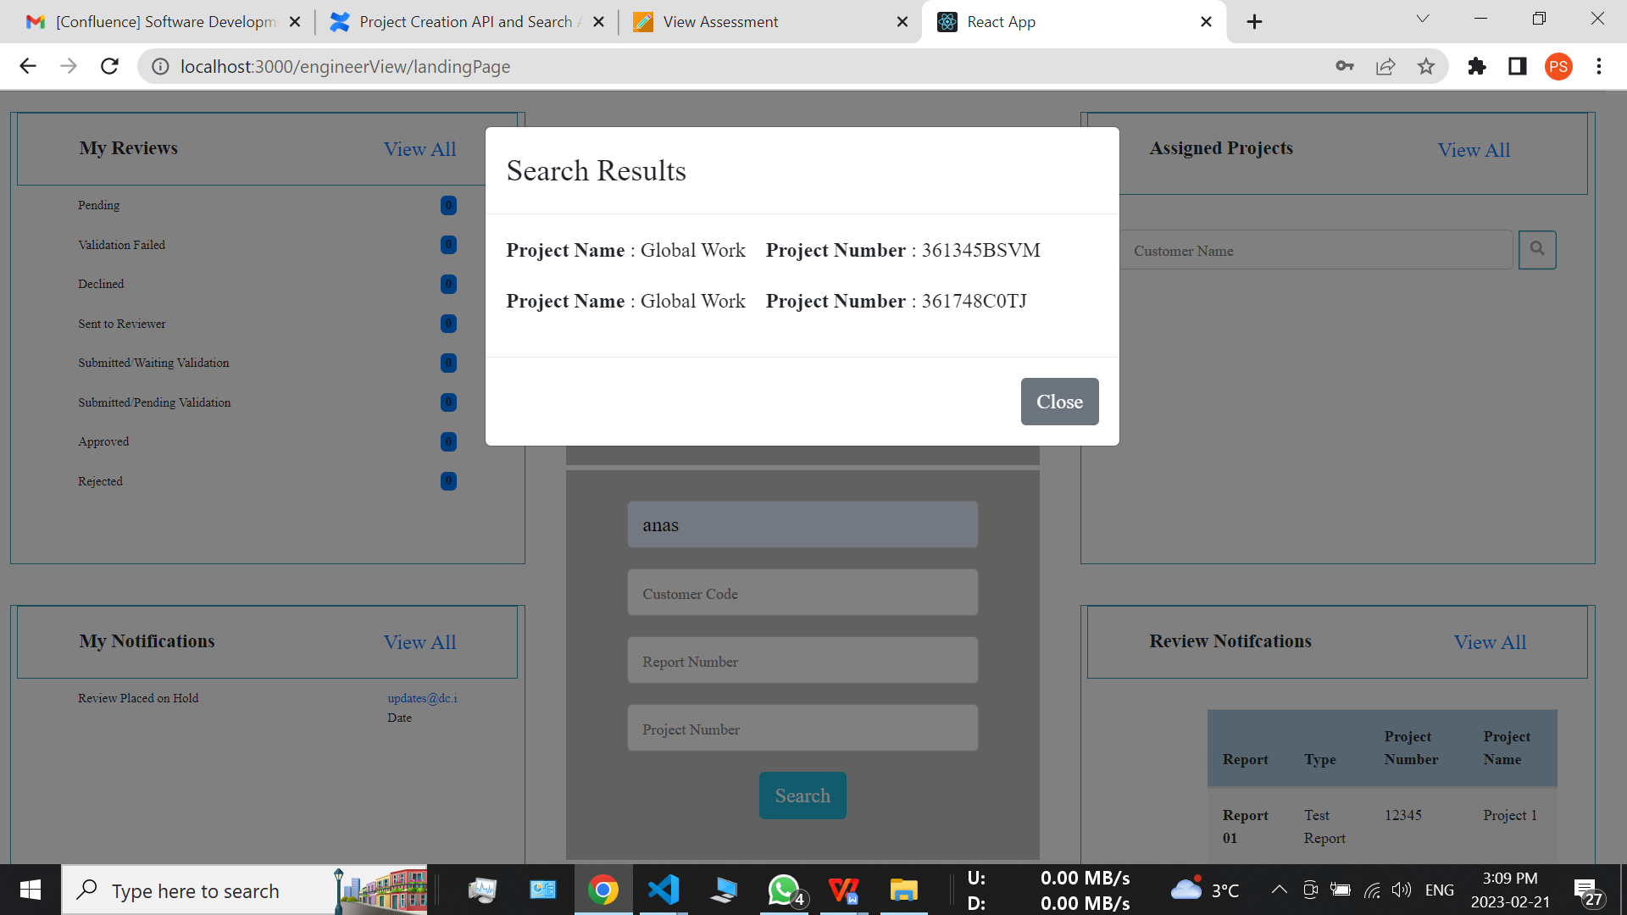

CREATE PROJECT FOLDER : SUCCESS MESSAGE AFTER CLICKING CREATE PROJECT FOLDER

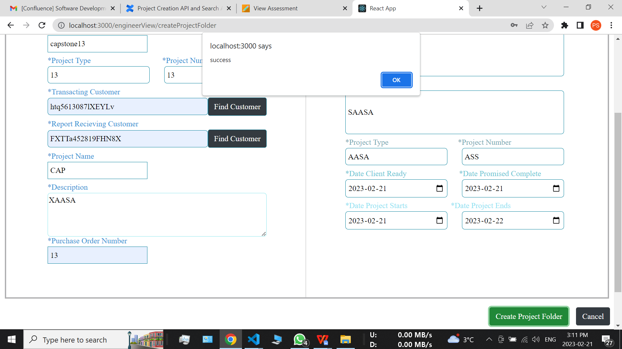

PAGES INTEGERATE(TOTAL 6(DELIVERABLES, FINANCIALS, SUPPORTING DOCUMENTS, CORRESPONDENCE, EQUIPMENT LOG, DETAILS)

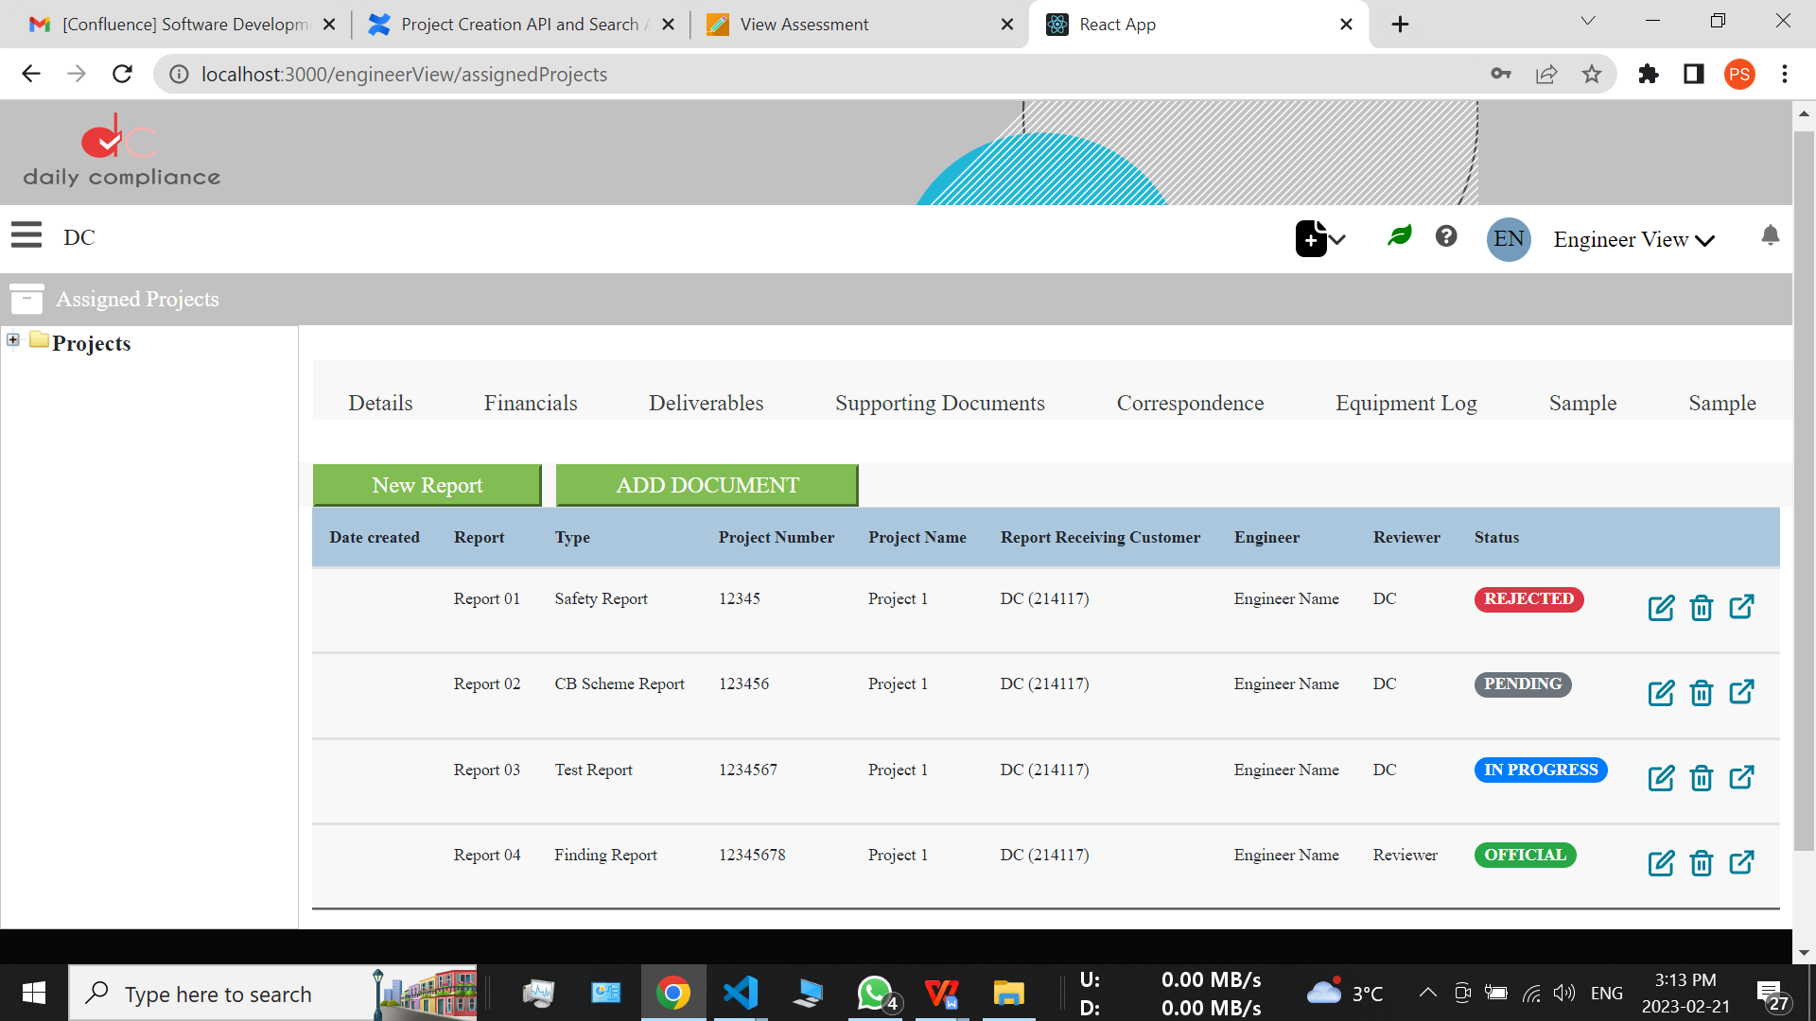

Planning for this week :

* Will be working on APIs further integeration. Showing results on separate page after successful hits … Further Improving User Experience
* Will be discussing with sponsors(tomorrow is our meeting) for next steps